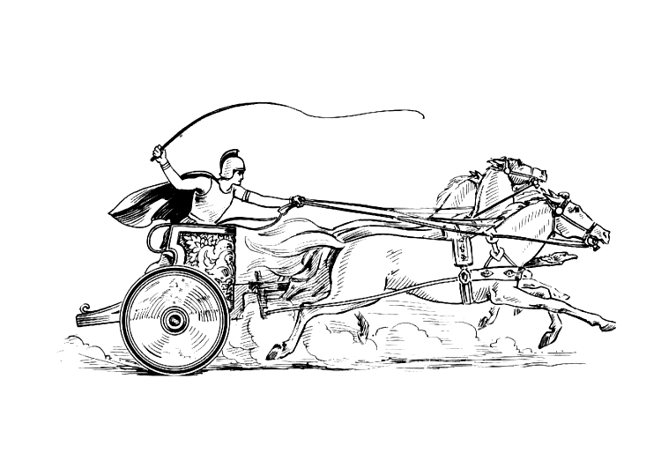Manduessedum - Mancetter Village (Place of War Chariots)
Mancetter Parish Council
Serving the People of Mancetter and Ridge Lane

You are invited to the Parish Council Meeting
to be held in the Schoolroom of St Peter’s Church Mancetter
on Tuesday 23rd January 2024 at 7pm.

AGENDA

- Welcome and Apologies.

- Chairman’s request that anyone recording the meeting make themselves known, to allow
openness and recognise practicalities.

- Declared Notice of Interest by Councillors concerning Agenda Items.

- Public Question time of up to 15 Minutes for Members of the Public to raise issues.

- Police, County and Borough Councillor feedback.

- Minutes of the last meeting.

To accept the draft minutes of the Parish Council Meeting held on 28th November 2023.

- Matters Arising from the Parish Council Meeting on 28th November 2023.

- Engagement with NWBC on use of section 106 funding for Ridge Lane Recreation Ground and continuing issues with dog fouling.

- Feedback from Correspondence, Consultations and Meetings involving the Parish
Council.

- Update on A5 Proposals, including Woodford Lane and the A5 Corridor. Potential meeting on 2nd February to discuss issues with Craig Tracey MP.
- Forthcoming Quarry Meetings at Tarmac and Restoration Planning with WCC at Shire Hall.
- Online Police Precept Meeting feedback 1st December 2023.
- Levelling up meeting progress 16th January 2024 at Mancetter Memorial Hall.
- Online Town and Parish Council Reference Group Meeting 18th January 2024
- Updates on current Public Consultations: Rights of Way Improvement Plan,
Fire and Rescue Service delivery model and Household Waste Recycling.

- Planning Matters and New Applications since the previous meeting:

- Planning Matters

- Feedback from Enforcement on Manor Road Car Sales development.
- Heritage Officer comments on Land to the rear of 90-92 Mancetter Road.
- Update on unauthorised access to the rear of the Coppice in Mancetter.

- Update on Approved and Pending Applications

- PAP/2023/0280 – Sovereign Motor Company – Proposed extension to existing vehicle workshop to be used as an MOT facility. – Granted

- PAP/2023/0283 – Sovereign Motor Company – Change of use for part of site to vehicle sales - Granted

- PAP/2023/0324 – Outline Access application for construction of three dwellings to the rear of the White Hart Inn Ridge Lane. – Pending.

- PAP/2023/0334 – Change of use from Agricultural to Residential The Dutch Hay Barn Whitehall Farm Atherstone Road Hartshill – Granted as Permitted Development.

- PAP/2023/0460 and PAP/2023/0464 - Listed applications for replacement windows at the grade II listed Railway Cottage in Quarry Lane –0460 Listed Building Consent Granted. 0464 Secondary Glazing Pending.

- Finance.

- Signing of all payments since the last meeting in accordance with Standing Orders and the Bank Mandate.

- To approve a finalised budget for the financial year 2024 – 2025.

- To formally agree the Parish Council precept request for the financial year 2024 – 2025.

- To authorise the Chairman to collect the Allotment rents for the next season and updates on the waiting list and the plot mentoring scheme.

- Cemetery and Maintenance around the Parish

- Update on installation of the new parish noticeboards.
- Feedback from Flood Warnings at the Mancetter Gauge.
- Review of Cemetery Bench Policy to consider a replacement local supplier / use of recycled materials.
- Changes to Cemetery Management Processes and risk assessment review.

- Date of next meeting-

TUESDAY 26th March 2024
7PM AT ST PETERS CHURCH SCHOOLROOM.

Signed 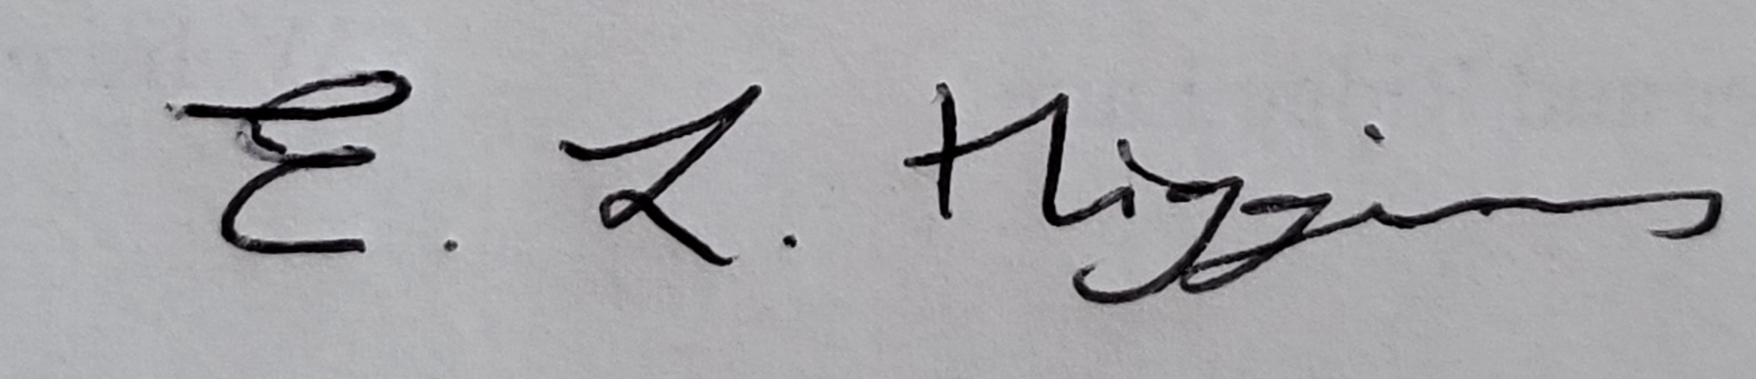

Date 18th January 2024.

Elane Higgins
Parish Clerk Mancetter Memorial Hall Old Farm Road Mancetter CV9 1QN Tel: 01827 722552 Email: parishclerk@mancetter.org.uk
Website: www.mancetter.org.uk

Manduessedum - Mancetter Village
(Place of War Chariots)
Mancetter Parish Council
Serving the People of Mancetter and Ridge Lane

